# Voyager Skeleton

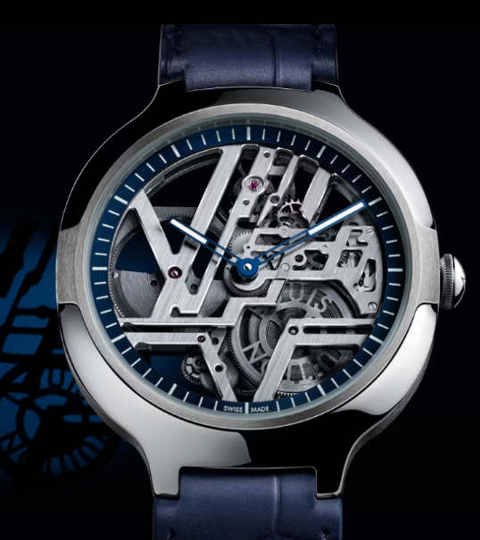

A Journey inside the Movement

This exclusive timepiece embodies the audacious design codes of the Maison, making its debut in eternally lustrous platinum.

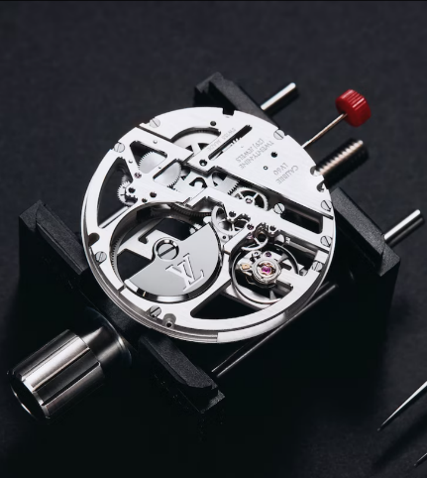

Inspired by contemporary architectural lines and forms, this timepiece carries Louis Vuitton’s first automatic skeleton movement, showcasing the avant-garde aesthetic and innovative savoir-faire of the Maison, in a limited-edition of 150 pieces.

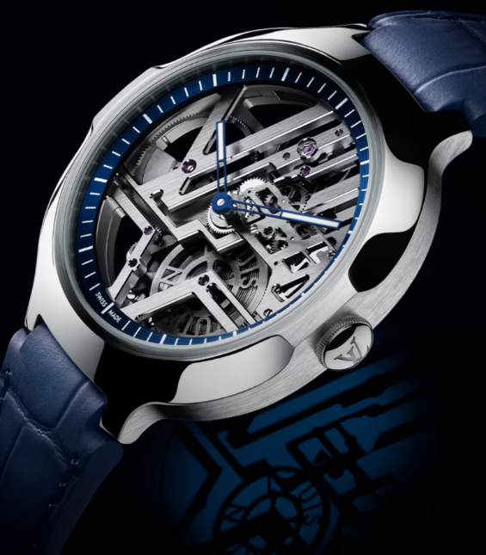

Expertly designed by La Fabrique du Temps Louis Vuitton, the intricate details of this timepiece are a work of art.

The transparency of the skeletonized movement reveals the caliber mechanics as well as the Louis Vuitton-signed barrel, made visible by the off-center placement of the micro-rotor.